Introduction to VPC
What is a VPC?
Amazon Virtual Private Cloud (VPC) allows you to launch AWS resources in a logically isolated network that you define. You have complete control over your virtual networking environment, including selecting your own IP address range, creating subnets, and configuring route tables and gateways.
Key Features of a VPC:
- Logical Isolation: Operates within a region, providing control over network setup.
- Subnets: Divide your VPC into smaller segments based on your requirements.
- Security: Use security groups and network ACLs for fine-grained control.
- Internet Gateway: Attach to a VPC for internet access.
Private Connectivity: Use VPN or Direct Connect to connect on-premises environments.
- Elastic IPs: Assign static IP addresses to resources in your VPC.
VPC Types:
- Default VPC: Automatically created by AWS in each region. It includes a public subnet in each Availability Zone, enabling immediate access to AWS services.
- Custom VPC: Created manually to meet specific networking requirements, offering full control over the network configuration.
Reserved IPs in AWS:
Within each subnet's CIDR block, AWS reserves the following IP addresses:
- .0: Network address.
- .1: Reserved by AWS for the VPC router.
- .2: Reserved for mapping Amazon-provided DNS.
- .3: Reserved for future use.
- Last IP: Reserved for the network broadcast address.
For example, in a /24 subnet (192.168.1.0/24):
- Reserved IPs: 192.168.1.0, 192.168.1.1, 192.168.1.2, 192.168.1.3, and 192.168.1.255.

CIDR Calculation for Subnets
What is CIDR?
Classless Inter-Domain Routing (CIDR) is a method for allocating IP addresses and routing. Instead of using the traditional class-based system, CIDR allows IP ranges to be split into subnets with flexible sizes.
CIDR Notation:
A CIDR block is expressed as IP address/prefix length. For example, 192.168.0.0/24:
- 192.168.0.0: Network portion.
- /24: Indicates that the first 24 bits represent the network, leaving 8 bits for host addresses.
Subnetting Calculation:
- Determine the Number of Hosts:
  - Formula: 2^(32 - prefix length) - 2
  - Example: /24 = 2^(32 - 24) - 2 = 254 usable hosts
- Divide a Larger Block:
  - Example: To split 10.0.0.0/16 into four subnets, increase the prefix length to /18. Resulting subnets:
    - 10.0.0.0/18
    - 10.0.64.0/18
    - 10.0.128.0/18
    - 10.0.192.0/18
Practical Example:
- Base CIDR: 10.0.0.0/16
- Required Subnets: 4
- Step: Adjust prefix length to /18 to accommodate each subnet.

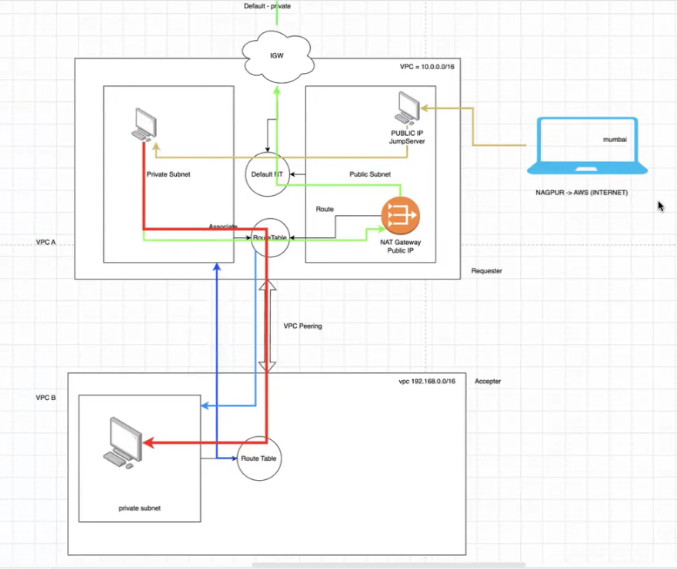
Create VPC and Subnet
Step-by-Step Guide:
Create a VPC:
- Log in to the AWS Management Console.
- Navigate to VPC Dashboard.
- Click Create VPC.
- Provide details:
  - Name: MyVPC
  - IPv4 CIDR Block: 10.0.0.0/16
  - Enable DNS settings if required.
- Click Create VPC.
Create a Subnet:
- Go to the Subnets section in the VPC Dashboard.
- Click Create Subnet.
- Select your VPC (e.g., MyVPC).
- Specify details:
  - Name: PublicSubnet
  - Availability Zone: Choose an AZ (e.g., us-east-1a).
  - CIDR Block: 10.0.0.0/24
- Click Create Subnet.
Verify:
- Go to the VPC Dashboard.
- Confirm that your VPC and Subnet appear in the list.
- Associate your subnet with a route table if necessary.


1. Create an Internet Gateway (IGW) and Route
What is an IGW?
An Internet Gateway is a horizontally scaled, highly available, and redundant VPC component that allows communication between instances in your VPC and the internet.
Steps to Create an IGW and Attach to VPC:
- Navigate to the AWS Management Console:
  - Go to the "VPC" section.
- Create an Internet Gateway:
  - Select "Internet Gateways" from the left-hand menu.
  - Click "Create internet gateway."
  - Provide a name for the IGW (optional).
  - Click "Create internet gateway."
- Attach the IGW to a VPC:
  - Select the IGW you just created.
  - Click "Actions" → "Attach to VPC."
  - Select the desired VPC from the dropdown list.
  - Click "Attach internet gateway."
Create a Route Table and Associate with Subnets:
- Navigate to Route Tables:
  - Under the "VPC" dashboard, click "Route Tables."
- Create a Route for Internet Access:
  - Select the route table associated with the public subnet.
  - Click on the "Routes" tab and "Edit routes."
  - Add a route:
    - Destination: 0.0.0.0/0
    - Target: Select the Internet Gateway ID.
  - Click "Save routes."
- Associate the Route Table with the Subnet:
  - Go to the "Subnet Associations" tab.
  - Click "Edit subnet associations."
  - Select the public subnet.
  - Click "Save."
2. Launch Private and Public Instances
Public Instance:
- Ensure Public Subnet Configuration:
  - Verify that the subnet is associated with a route table pointing to an Internet Gateway.
- Launch an EC2 Instance:
  - Navigate to the EC2 dashboard.
  - Click "Launch Instance."
  - Select an AMI (e.g., Amazon Linux 2).
  - Choose an instance type.
  - In the "Configure Instance" step, select the public subnet.
  - Enable "Auto-assign Public IP."
  - Add storage and tags as needed.
  - Configure a security group to allow SSH (port 22).
  - Launch the instance.
Private Instance:
- Ensure Private Subnet Configuration:
  - The subnet should not be associated with a route to an Internet Gateway.
- Launch an EC2 Instance:
  - Follow the same steps as for a public instance.
  - In the "Configure Instance" step, select the private subnet.
  - Ensure "Auto-assign Public IP" is disabled.

3. NAT Gateway
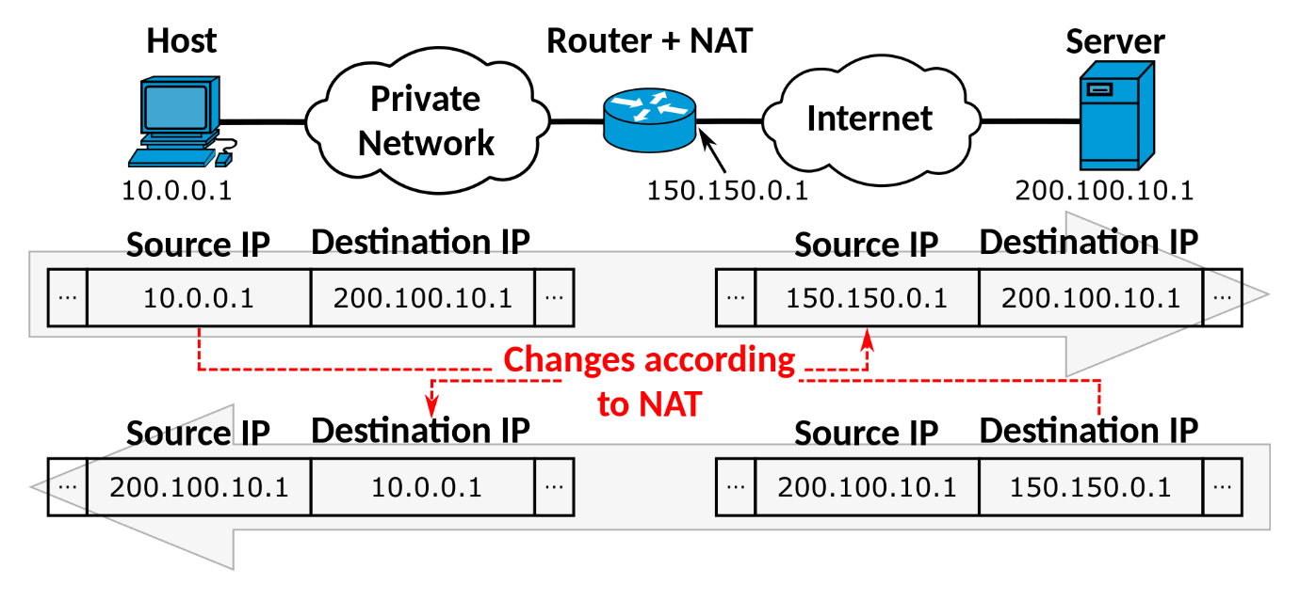
What is a NAT Gateway?
A Network Address Translation (NAT) Gateway enables instances in a private subnet to access the internet while preventing unsolicited inbound traffic from the internet.
Steps to Create a NAT Gateway:
- Navigate to NAT Gateways:
  - Under the "VPC" section, click "NAT Gateways."
- Create a NAT Gateway:
  - Click "Create NAT gateway."
  - Select the public subnet.
  - Allocate an Elastic IP (EIP) for the NAT Gateway.
  - Click "Create NAT gateway."
- Update Route Table for Private Subnet:
  - Go to "Route Tables."
  - Select the route table associated with the private subnet.
  - Click on the "Routes" tab and "Edit routes."
  - Add a route:
    - Destination: 0.0.0.0/0
    - Target: Select the NAT Gateway ID.
  - Click "Save routes."
4. VPC Peering
What is VPC Peering?
VPC Peering is a networking connection between two VPCs that enables you to route traffic between them using private IP addresses.
Steps to Create a VPC Peering Connection:
- Create a Peering Connection:
  - Navigate to the "VPC" dashboard.
  - Click "Peering Connections."
  - Click "Create peering connection."
  - Provide a name for the connection.
  - Select the requester VPC and the accepter VPC (can be in the same or different AWS accounts).
  - Click "Create peering connection."
- Accept the Peering Connection:
  - If the accepter VPC is in the same account:
    - Select the peering connection.
    - Click "Actions" → "Accept request."
  - If in a different account, log in to the other account, navigate to "Peering Connections," and accept the request.
- Update Route Tables for Communication:
  - Go to "Route Tables" in both VPCs.
  - Edit the routes to allow traffic to the CIDR block of the peer VPC.
  - Also make sure ICMP port is open in security groups for both instances, for ping purposes.
- Update Security Groups:
  - Ensure security group rules allow traffic between instances in the peered VPCs

